
Computer Science Department
CPCS223 Analysis and Design of Algorithms
Group Project
Theoretical and Empirical analysis study

Student Name | Student ID
Sultan Yasir Alasami | 2339663
Ryan Abdullah Alsheri | 2336103
Khaled Alshehri | 2338428
Turki alharbi | 2338473

a) Theoretical Analysis of Insertion Sort (by giving appropriate asymptotic notation)
Sol)
Time Complexity:
- Best Case (Already Sorted): O(n)
- Average Case: O(n²)
- Worst Case (Reverse Sorted): O(n²)
Space Complexity: O(1) (In-place sorting)

b) Theoretical Analysis of Merge Sort (by giving appropriate asymptotic notation)
Sol)
Time Complexity:
- Best Case: O(n log n)
- Average Case: O(n log n)
- Worst Case: O(n log n)
Space Complexity: O(n) (Additional space for merging)

c) Theoretical Analysis of Quick Sort (by giving appropriate asymptotic notation)
Sol)
Time Complexity:
- Best Case (Balanced Partitions): O(n log n)
- Average Case: O(n log n)
- Worst Case (Unbalanced Partitions, e.g., Sorted/Reverse Sorted): O(n²)
Space Complexity:
- Best/Average Case: O(log n) (Recursive stack space)
- Worst Case: O(n) (Degenerate recursion depth)

d) Comparison of all three sorting algorithms:
Value of N | Run Type | Insertion Sort (Nanosecond) | Merge Sort (Nanoseconds) | Quick Sort  (Running time in Nanoseconds)
N = 10 | Completely unsorted | 1779 | 5999 | 28220
 | Partially sorted | 2420 | 9059 | 16900
 | Nearly sorted | 3440 | 9860 | 7939
N = 100 | Completely unsorted | 48680 | 34639 | 62380
 | Partially sorted | 29099 | 8140 | 67980
 | Nearly sorted | 10060 | 22720 | 33999
N = 1000 | Completely unsorted | 1092119 | 188400 | 165080
 | Partially sorted | 677639 | 369400 | 377120
 | Nearly sorted | 155379 | 154159 | 133280
N = 10000 | Completely unsorted | 11381900 | 1295040 | 1081540
 | Partially sorted | 5492459 | 599700 | 766940
 | Nearly sorted | 1620020 | 781760 | 1227020
N = 100000 | Completely unsorted | 1003837659 | 13458480 | 16193320
 | Partially sorted | 475229339 | 6844259 | 12896840
 | Nearly sorted | 114969540 | 7422160 | 12069520
Average Time |  | 2546.33 | 8306.00 | 17686.33

Show bar graph with three bars, one for each sorting algorithm, constructed based on their average running time.
Sol)
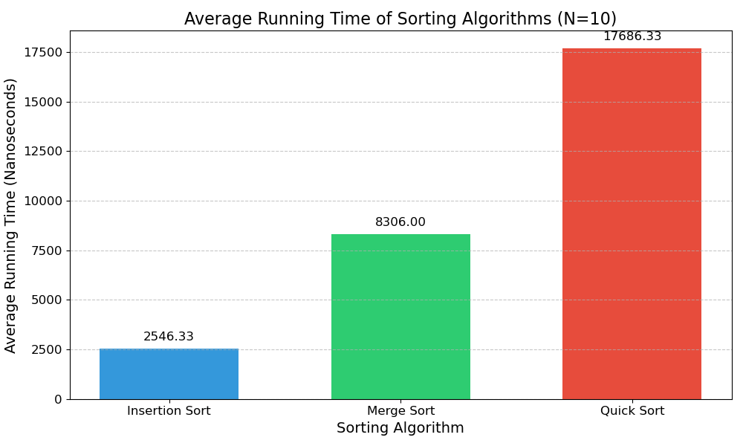
e) For part 3, make your analysis and experimentation and give the reasons for adopting the two pivot version. The answer must be well-argued and explained using both experimental and/or theoretical results.
Sol)

Following are the reasons as to why the two pivot version was adopted:
1. Improved Partitioning:
- Dual-pivot QuickSort divides the array into three parts: elements smaller than the first pivot, elements between the two pivots, and elements greater than the second pivot.
- This results in more balanced partitions, leading to fewer recursive calls and a faster sorting process compared to single-pivot QuickSort.
2. Better Performance:
- The dual-pivot method helps improve the average-case performance by reducing the number of swaps and comparisons, especially with random data.
- It is faster than single-pivot QuickSort in most cases, as it reduces partitioning overhead.
3. Time Complexity:
- Average Case: Both single-pivot and dual-pivot QuickSort have O(n log n) time complexity.
- Worst Case: Both algorithms have a worst-case time complexity of O(n^2), but dual-pivot QuickSort reduces the likelihood of hitting this scenario due to better partitioning.
4. Space Efficiency: Dual-pivot QuickSort is in-place, using only O(log n) extra space, unlike Merge Sort, which needs additional memory for merging. This makes dual-pivot QuickSort more space-efficient.
5. Experimental Results: Dual-pivot QuickSort is faster for large, randomly shuffled data, and is more cache-friendly, improving real-world performance.

All in all, Java adopted dual-pivot QuickSort for its faster performance, better partitioning, and space efficiency in handling large datasets, making it more suitable than the single-pivot version for most sorting tasks.

